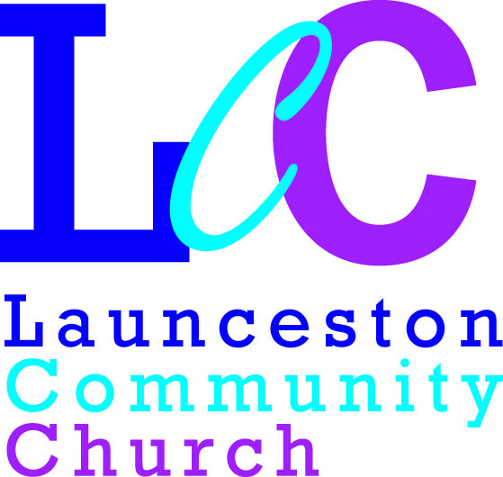
Launceston Community Church
Safeguarding Statement

PROTECTION OF CHILDREN AND VULNERABLE ADULTS POLICY STATEMENT

The following statement was agreed by the leadership/organisation* on: 30th September 2020

- This place of worship is committed to the safeguarding of children and adults with care and support needs and ensuring their well-being.

- We recognise that we all have a responsibility to help prevent the physical, sexual, psychological, financial and discriminatory abuse and neglect of adults at risk of harm and abuse and to report any such abuse that we discover or suspect.

- We recognise that the personal dignity and rights of adults and will ensure all our policies and procedures will reflect this.

- We believe all adults should enjoy and have access to every aspect of the life of the place of worship.

- We undertake to exercise proper care in the appointment and selection of those who will work with children and adults with care and support needs.

- We believe every child should be valued, safe and happy. We want to make sure that children we have contact with know this and are empowered to tell us if they are experiencing significant harm.

We are committed to:

- Following statutory denominational and specialist guidelines in relation to safeguarding children and adults and will ensure that as a place of worship/organisation all workers will work within the agreed procedure of our safeguarding policy.

- Implementing the requirements of the Disability Discrimination Acts 1995 and 2005, Equality Act 2010 and all other relevant legislation.

- Supporting, resourcing and training those who undertake this work.

- Ensuring that we are keeping up to date with national and local developments relating to safeguarding.

- Ensuring that everyone agrees to abide by these recommendations and the guidelines established by this place of worship/organisation.

- Supporting all in the place of worship/organisation affected by abuse.

We recognise:

- Children’s Social Services has lead responsibility for investigating all allegations or suspicions of abuse where there are concerns about a child. Adult Social Care has lead responsibility for investigating all allegations or suspicions of abuse where there are concerns about an adult with care and support needs.

- Where an allegation suggests that a criminal offence may have been committed then the police should be contacted as a matter of urgency.

Safeguarding is everyone’s responsibility.

We will review this statement and our policy annually.

If you have any concerns for a child or adult, then speak to one of the following who have been approved as safeguarding co-ordinators for this place of worship.

Rachel Bate: Mobile: 07837157297 Safeguarding Co-Ordinator

Chris Biddle: Mobile: 07849158758 Deputy Safeguarding Co-Ordinator

Contact Phone Numbers:

Multi Agency Referral Unit (MARU)
Cornwall Council Social Services
Children: 0300 1231 116
Out of Hours: 01028 251300

Adult Referral:
Tel: 0300 1234 131

Police Protection Team
Tel: 08452 777444

